

**Advanced Web Technologies Report**

**40326941-ISMAEL SOUF**

**Abstract**

In today’s society a website is the most powerful tool of communication. A website is the chance to connect with the world. There is no space better than the internet to get in touch with a broad international audience and it is often the first place where people go when they want to learn more about a topic.

The aim of this coursework is to demonstrate an understanding of the server-side web development and mastery of the Python Flask micro-framework.

The first part of this assignment is a report in which I will talk about the features, analysis, design, and plan for implementation of my web-app.

The topic I have chosen for this web application is based on Islam religion and how Muslims live.

1. **Description of my planning**.

T-I is a web application I’m planning to create in order to share a user interface that provides the user a good experience about the topic. The web-app is going to be a teaching website. There will be the possibility to create an account in order to post events, view other events, ask about information and to participate to a quiz.

The site will consist of many pages which can be accessed via a navigation bar only if the user is logged in. From the navigation bar the user will be able to navigate through pages to read information, to ask question, to post events related to the topic, participate to quiz…

The main goal of the web application is to give an overview of the beautiful religion of Islam through a user experience with the features listed above.

1. **Summary of background research**

**Flask research**

Flask provides simplicity, flexibility and fine-grained control. According to my background reading and research the framework flask let me decide how I am going to implement things. I also looked at how I could add an audio on my future website which is now a feature I am going to add to my project.

**Design research**

I have spent few days looking on similar website about religion in order to have an idea of how I would like to start my project. In fact, I have discovered that the first page of every website related to religion include information to read but also things to listen to.

However, I think those website lack of animations and images that’s show the beauty of the religion and how it changes the life. Therefore, I realised that the quiz could be a potential and strong feature that could help the learning. I would like to add a quiz according to the information and images which will be in the whole project.

1. **List of features**

In order to create my project, we are going to use different features:

* The design will be consistent
* Profile experience
* User login
* Contact information
* Audio
* Security
* Post Event
* Quiz

First of all, what is the most important when starting a web application is to think about the **design** that we are going to share with the users. In fact, a good design will attract more than just a basic website in black and white. Then, if we need to store our messages, post or score of the quiz personally I think we would need **an account**. That is why I am going to give the opportunity to the user **to create an account and have a user profile**. Therefore, there will be the possibility to **change the password** of your account to **add more security**.

Finally, I will implement **a quiz** in order to help the user keep in mind the message of my web-app. When it’s come to quizzes it’s important to create one that **captures the interest of your audience** and effortlessly **guides them towards their next steps**.

1. **Navigation Tree**

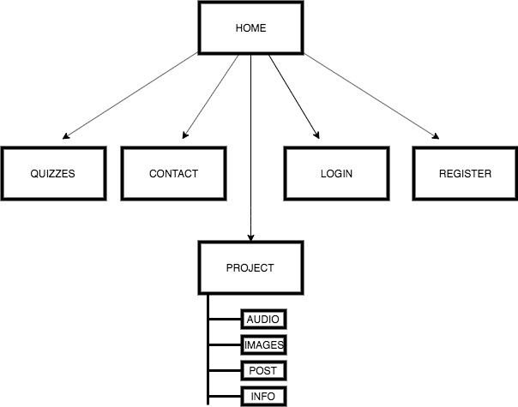

Navigation Tree 1.1

**Home page**: The home page will include a navigation bar in order to help the audience navigate around the website.

**Register**: This is the page where the user can create his account.

**Login**: Page to login and access to the project.

**Quiz**: Quiz about information and images visible on the website.

**Project**: This part is only accessible if the user has an account to login in order to see the real project which contain listening to audio, see various images, read information and send post on the website.

**Contact**: Page to contact the owner of the website in case of errors or to ask questions concerning the project.

1. **Sketch UI**

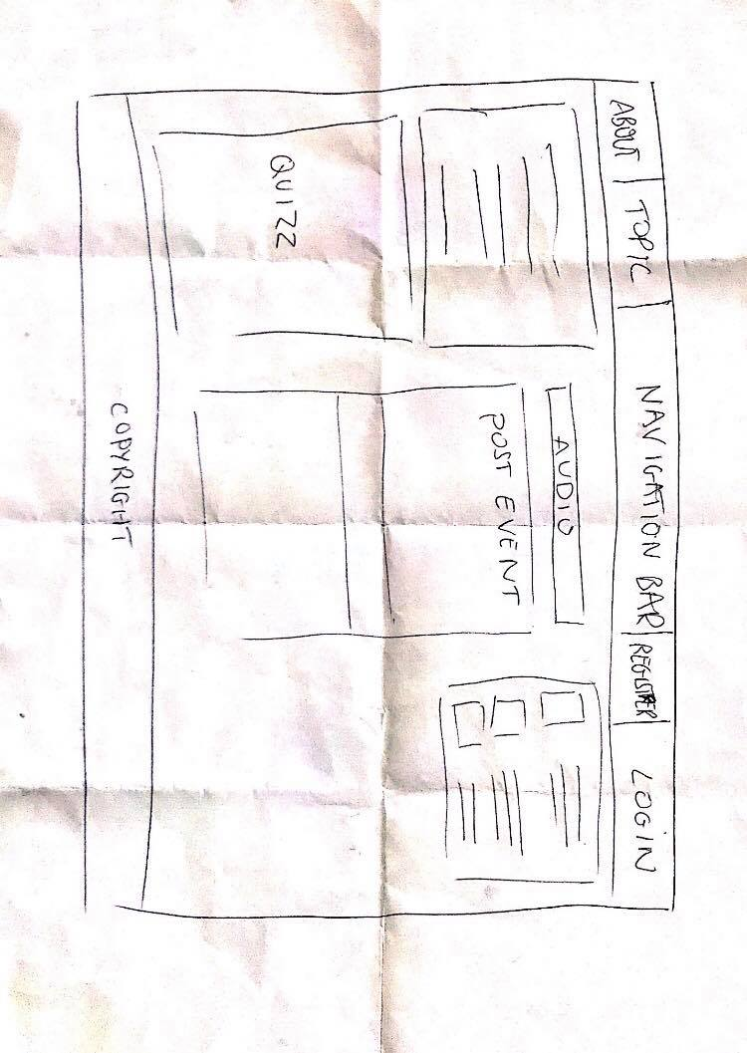

1. **RESTFUL API**

From my previous experience it’s pretty easy to build APIs Flask.